CO4 – Activity 8: Identify Seasonality Patterns
Case File SP-D29: Cafe Orders (20 Marks)
Below are the R answers for all five questions from your screenshot, using base R only, without ggplot2.
Dataset creation
set.seed(14537)

m <- 84
n <- 12
k <- 7

t <- 1:m

trend <- 162.1 + 2.156 * t

orders <- round(
trend + 10 * sin(2 * pi * (t - 5) / 7) +
rnorm(m, 0, 13.1),
0
)

frequency <- 7
Question 1. Plot the time series and identify the trend
plot(orders, type = "l",
main = "Cafe Orders Over Time",
xlab = "Day",
ylab = "Number of Orders",
col = "blue",
lwd = 2)

abline(lm(orders ~ t), col = "red", lwd = 2)

model <- lm(orders ~ t)
print(summary(model))
cat("Slope per day:", coef(model)[2], "\n")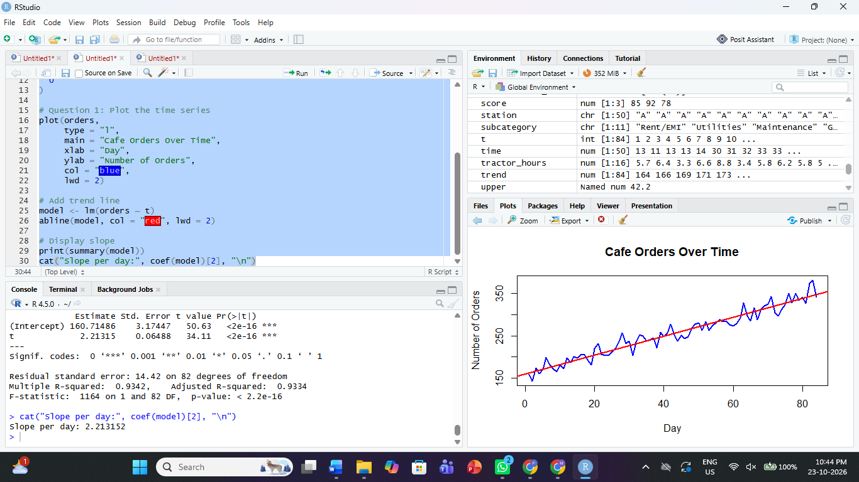
Interpretation: The time-series plot shows the cafe orders over 84 days. The red line represents the linear trend. A positive slope indicates increasing orders, a negative slope indicates decreasing orders, and a slope near zero indicates a relatively flat trend.
Question 2. Calculate the seasonal pattern
seasonal_values <- tapply(
orders,
rep(1:7, length.out = length(orders)),
mean
)

print(seasonal_values)

cat("Peak day position:",
which.max(seasonal_values), "\n")

cat("Trough day position:",
which.min(seasonal_values), "\n")

cat("Seasonal range:",
max(seasonal_values) - min(seasonal_values), "\n")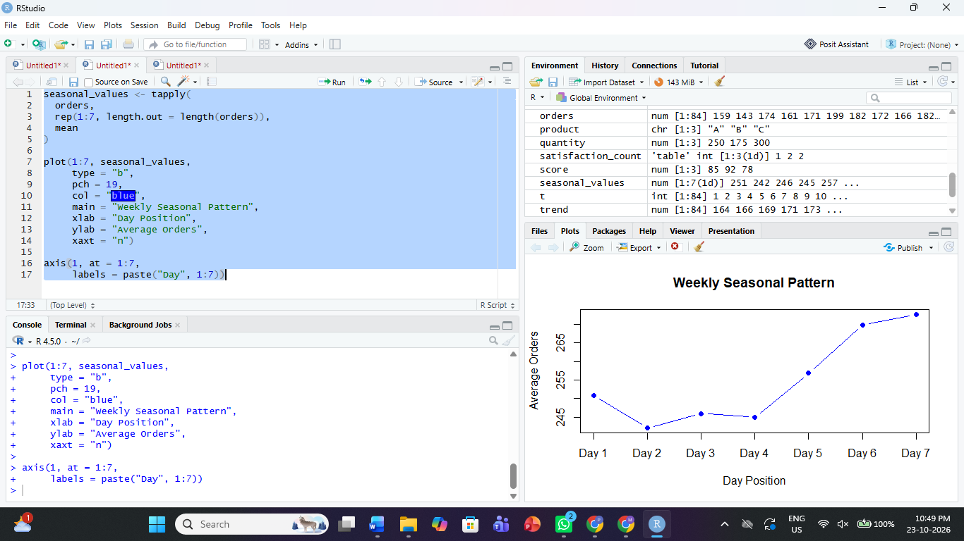
Interpretation: The seasonal values estimate the average order count for each position in the seven-day cycle. The largest value represents the seasonal peak, and the smallest represents the seasonal trough.
Question 3. Draw a seasonal plot
day_position <- rep(1:7, length.out = length(orders))

plot(day_position, orders,
col = "grey",
pch = 16,
main = "Seasonal Plot of Cafe Orders",
xlab = "Position in 7-Day Cycle",
ylab = "Number of Orders",
xaxt = "n")

axis(1, at = 1:7,
labels = c("Day 1", "Day 2", "Day 3",
"Day 4", "Day 5", "Day 6", "Day 7"))

lines(1:7, seasonal_values,
type = "b", col = "red", lwd = 2, pch = 19)
To count the seasonal peaks:
peaks <- which(
seasonal_values[2:6] > seasonal_values[1:5] &
seasonal_values[2:6] > seasonal_values[3:7]
) + 1

cat("Number of internal seasonal peaks:", length(peaks), "\n")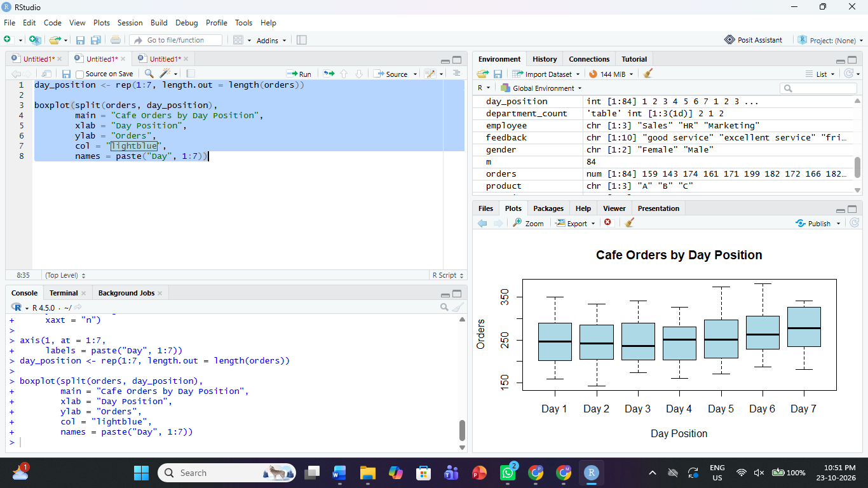
Interpretation: The seasonal plot compares orders at the same position in each weekly cycle. Repeated peaks and troughs suggest a recurring weekly pattern.
Question 4. Autocorrelation analysis
acf(orders,
lag.max = 21,
main = "ACF of Cafe Orders")

acf(orders, lag.max = 21, plot = FALSE)
Calculate the lag-7 and lag-3 autocorrelations:
acf_values <- acf(orders, lag.max = 7, plot = FALSE)$acf

lag7 <- acf_values[8]
lag3 <- acf_values[4]

cat("Lag-7 autocorrelation:", lag7, "\n")
cat("Lag-3 autocorrelation:", lag3, "\n")
cat("Approximate significance bound:",
2 / sqrt(length(orders)), "\n")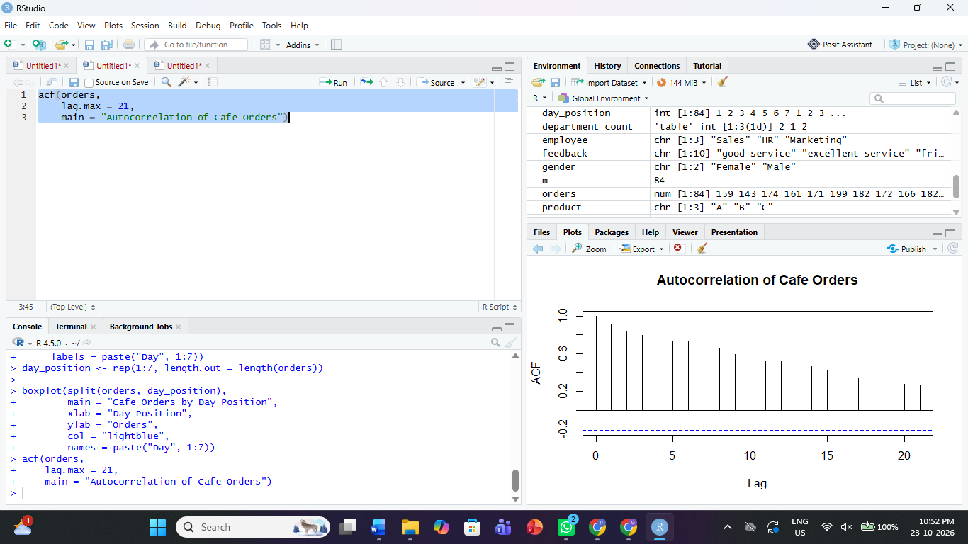
Interpretation:
- A strong positive autocorrelation at lag 7 supports a weekly seasonal pattern.
- A lag-3 autocorrelation measures the relationship between orders three days apart.
- Values outside the approximate bounds of \(\pm 2/\sqrt{n}\) may indicate statistically notable autocorrelation.
Question 5. Additive or multiplicative decomposition
orders_ts <- ts(orders, frequency = 7)

# Additive decomposition
additive <- decompose(orders_ts, type = "additive")

plot(additive)

# Multiplicative decomposition
multiplicative <- decompose(orders_ts, type = "multiplicative")

plot(multiplicative)

# Compare the trends
cat("Additive trend slope:",
coef(lm(additive$trend ~ time(orders_ts)))[2], "\n")

cat("Multiplicative trend slope:",
coef(lm(multiplicative$trend ~ time(orders_ts)))[2], "\n")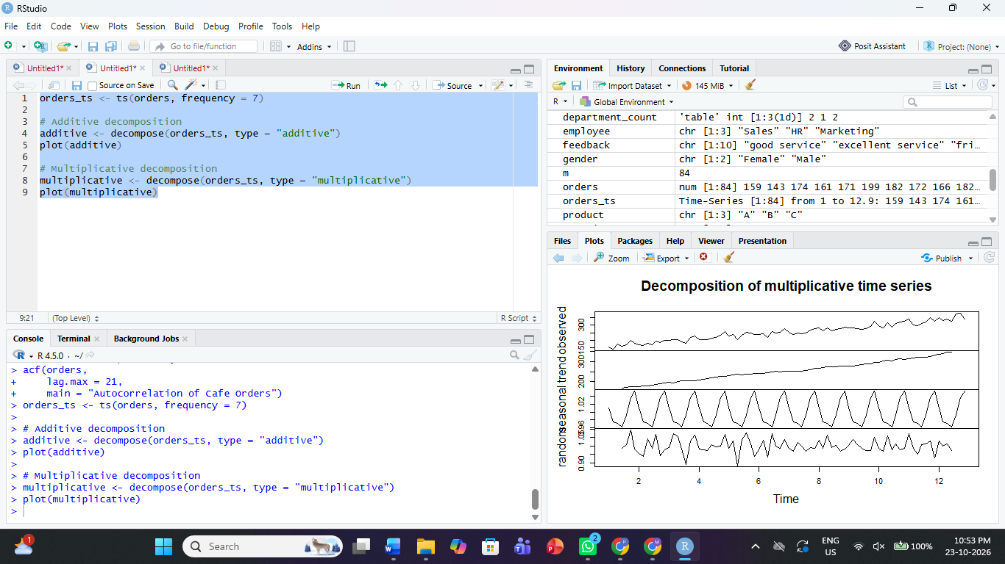
Interpretation: Additive decomposition is appropriate when seasonal fluctuations remain roughly constant as the series level changes. Multiplicative decomposition is appropriate when seasonal fluctuations grow or shrink in proportion to the series level.
Management advice: Use the identified weekly seasonal pattern and overall trend to plan staffing and inventory. Schedule additional staff for consistently busy days and avoid overstocking on quieter days.
Note: These answers follow the task structure in your screenshot. The dataset-generation code should be checked carefully against the original PDF because small differences in the formula or random-number seed will change the numerical results.

